Pulse Amplitude Modulation with 5 levels (PAM-5)
PAM-5 is the signaling scheme used in Gigabit Ethernet (1000BASE-T) to transmit data over standard copper cabling. Instead of the binary approach where you have just two voltage levels (high/low), PAM-5 uses five distinct voltage levels to encode information, which allows more bits to be packed into each symbol period.

The core idea

Each symbol in PAM-5 represents one of five voltage levels: −2, −1, 0, +1, +2 (normalized units). Since 5 levels can encode log₂(5) ≈ 2.32 bits per symbol, Gigabit Ethernet uses groups of symbols with a trellis code to achieve the required throughput while adding forward error correction. The key tradeoff: you get higher data rates within the same bandwidth, but the receiver must distinguish between more closely spaced voltage levels, making it more sensitive to noise.

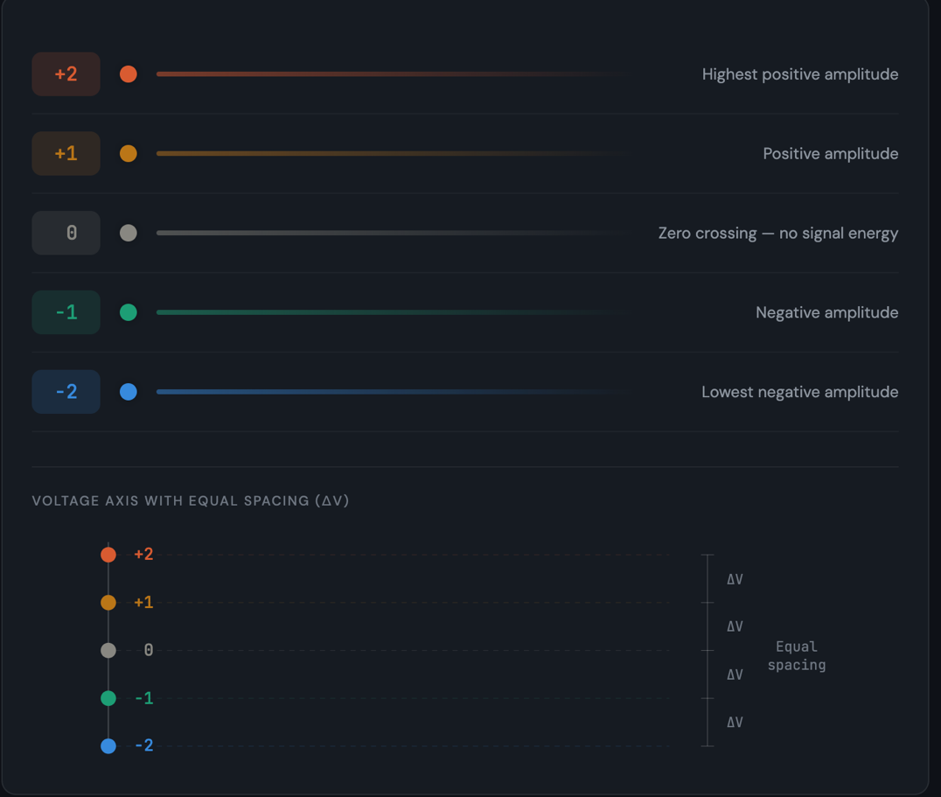

The five voltage levels are equally spaced. This uniform spacing maximises the noise margin between adjacent levels — each level sits exactly one "ΔV" apart from its neighbours.

How a PAM-5 waveform looks in practice
Now let's see how a sequence of symbols translates into an actual signal on the wire. Each symbol period, the transmitter sets the line voltage to one of the five levels. The receiver samples at each symbol boundary and decodes which level was sent.

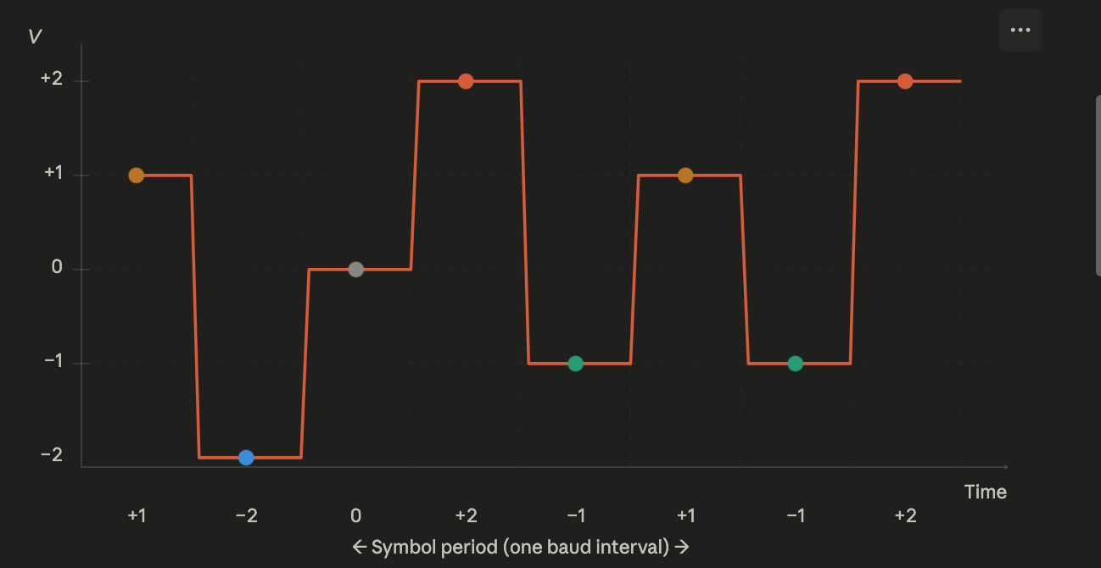
Each coloured dot is a sample point — the moment the receiver reads the voltage to determine which of the five levels was transmitted. The voltage transitions between symbol periods as the transmitter jumps from one level to the next.

Comparing PAM-2 vs PAM-5: why more levels matter
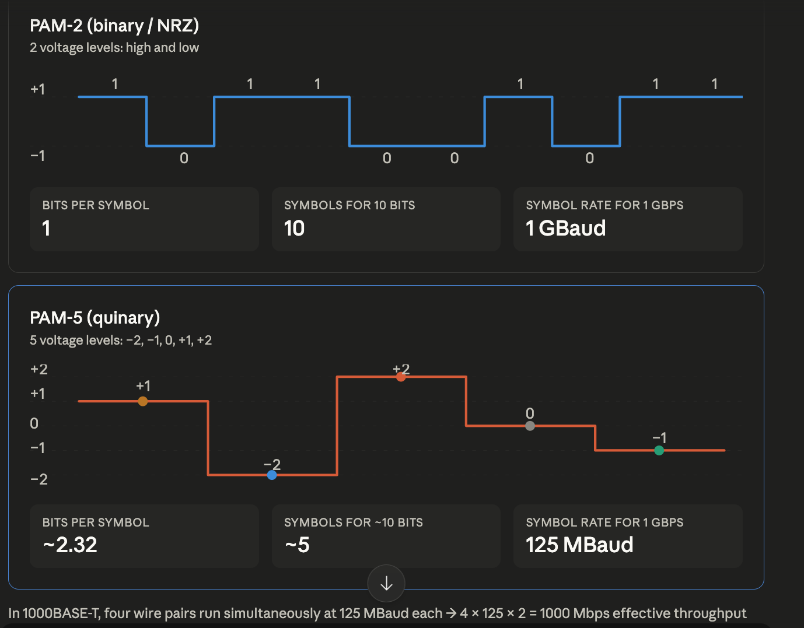
The fundamental advantage of PAM-5 over binary (PAM-2, or NRZ) signaling is spectral efficiency. With only two levels, you need one symbol per bit. With five levels, each symbol carries more information, so you can run the symbol rate slower for the same bit rate — which means less bandwidth on the cable.

This is the fundamental engineering tradeoff. PAM-2 needs a 1 GBaud symbol rate for Gigabit Ethernet — far too fast for Cat5 cable. PAM-5 drops that to 125 MBaud per pair. By running four pairs in parallel (full-duplex on each), you reach the full 1 Gbps.

pam5_binary_encoder

Key takeaways
PAM-5 works by encoding data into five equally spaced voltage levels rather than the two used in binary signaling. The three critical things to understand are:
Spectral efficiency — five levels yield ~2.32 bits per symbol, so you need fewer symbols per second for a given bit rate. This is precisely why 1000BASE-T can run at only 125 MBaud per pair instead of requiring a 1 GBaud clock that Cat5 cable cannot support.
Noise sensitivity — the spacing between adjacent levels (the "decision threshold") is smaller than in PAM-2, since the same peak-to-peak voltage range is divided into four gaps instead of one. This makes the receiver more vulnerable to crosstalk and thermal noise, which is why trellis-coded modulation (TCM) is added in the standard — it provides forward error correction at the cost of using one of the five levels as a redundant state.
Parallel transmission — Gigabit Ethernet uses all four twisted pairs in the cable simultaneously, each running PAM-5 at 125 MBaud. With the trellis code providing 2 effective data bits per symbol, you get 4 pairs × 125M × 2 = 1000 Mbps.

